

Final Project Report

SYST15829 - Interactive User Design

Guided under - Professor Himanshu

Date of Submission: Saturday, April 11th, 2020

Group Members: Daniel Ball, Minh Nguyen,

Nicholas Razack, Xingning Xu and Zawad Hossain

**Content**

Project Background :*Why Access Sheridan*

Project Outcome :*What Has Been Achieved*

Project Challenges :*What & How Could Have Been Better*

Field Study :*User Survey*

Project Implementation :*User Testing*

Project Tools : *Wireframing Software*

Project Analysis :*Initial Sketches, Initial Wireframes and Revised Wireframes*

Report Summary

**Project Background :*Why Access Sheridan***

We started off the project with a goal that is to improve on the current AccessSheridan web portal. A school’s web portal is a place where students distribute and receive information from professors. It also allows students/ professors and Sheridan staff to manage their courses, email, library resources, and financial accounts and other essential features.

**Project Outcome :*What Have Been Achieved***

Following the “Five Planes of UX”, it acted as a guide and gave an overview how the project is to be handled and what stages are there usually in developing such a project. It starts off from the abstract idea to a concrete prototype project.

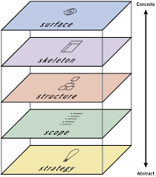

Fig : The 5 planes of User Experience

After finding a guideline, we needed a “requirement list” what actually our product have to do or needs to fulfill ie that is the “User Requirements” for that we carried out a survey to our targeted audience, they are the students of Sheridan, professors, lecturers and staff members. Within a two day notice we received an overwhelming response of 74, which shows that how much is needed of a change in the portal.

Having the requirement list

**Project Challenges :*What & How Could Have Been Better***

**Field Study :*User Survey***

**Project Implementation :*User Testing***

**Project Analysis :*Initial Sketches, Initial Wireframes and Revised Wireframes***

Based on our findings from User Requirements Survey data, we started working on the sketch of our webpage old school style with a pencil and paper.

**Initial Login Page Wireframe**

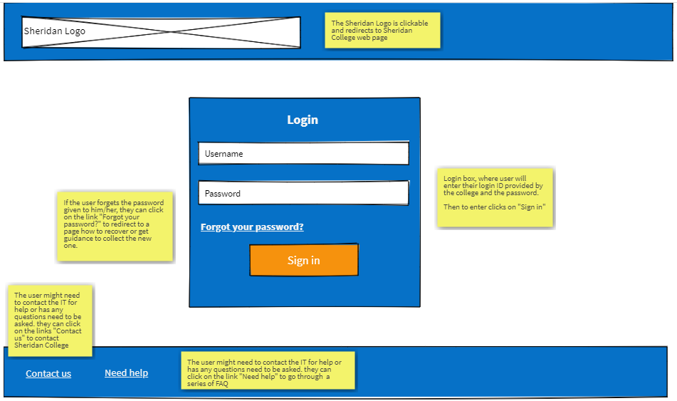

Figure 1a: Initial wireframe for our login page (wireframe pro)

**Revised Login Page Wireframe**

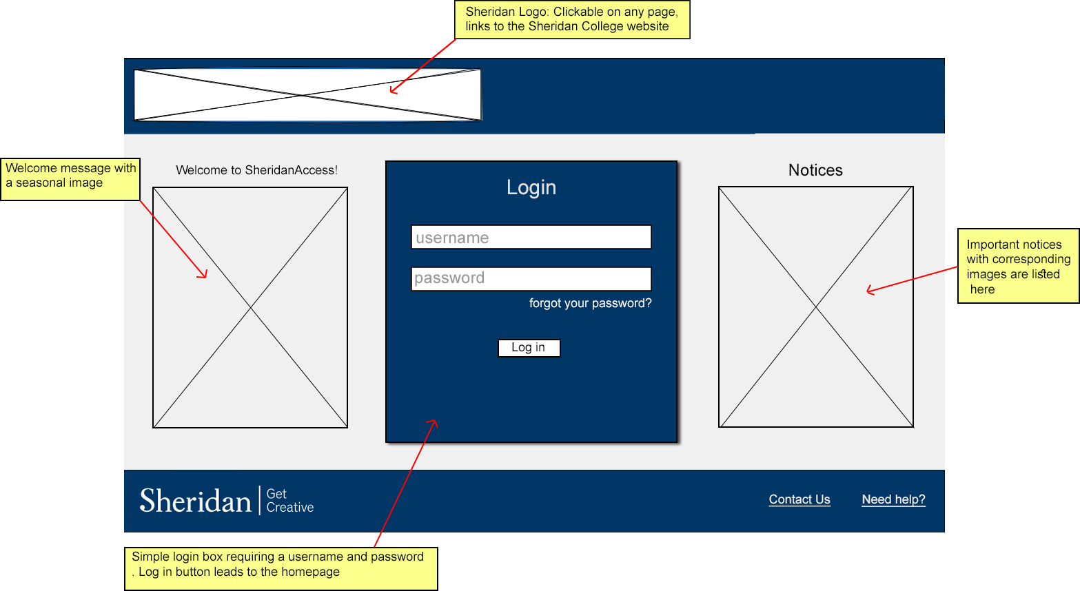

Figure 1b: Revised wireframe of login page

We changed the color scheme to a darker shade throughout the webpage and kept our login page simple. We added welcome notices to indicate that this is the login page according to suggestions from the user feedback. We also changed the header and footer of the web page to give it a more professional look.

**Initial Landing Page Wireframe**

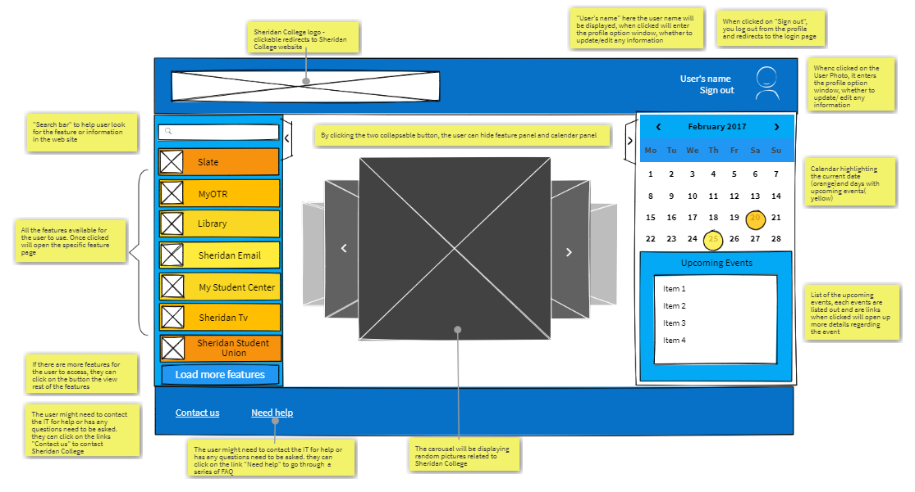

Figure 2a: Initial wireframe for our landing page (wireframe pro)

**Revised Landing Page Wireframe**

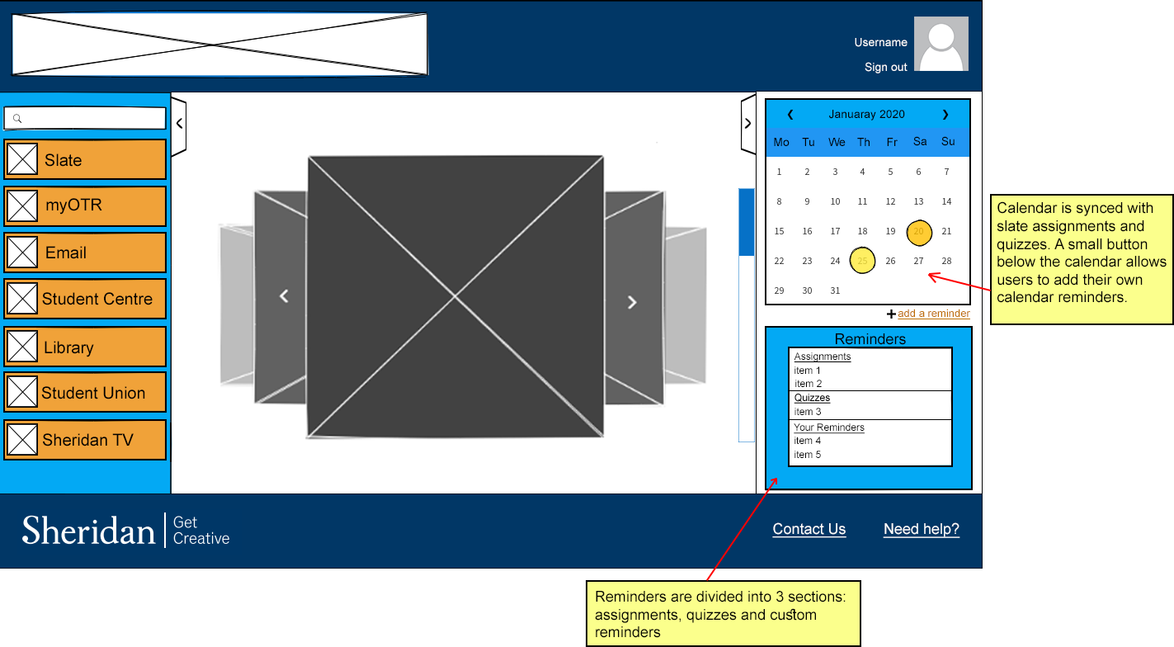

Figure 2b: Revised wireframe for our landing page

The color scheme for the Feature tabs on the left side is changed. Initial wireframe had a gradient of orange, now we simply stick to one shade. The darker shade of blue color is used throughout our webpage theme to give the website a distinct look that the users can become familiar with. The font is also adjusted to make the labels on the tabs more clear. We also changed the user profile pic logo on the top right corner. A new feature is added to the personal calendars to allow users to add their own reminders.

**Initial Search Page**

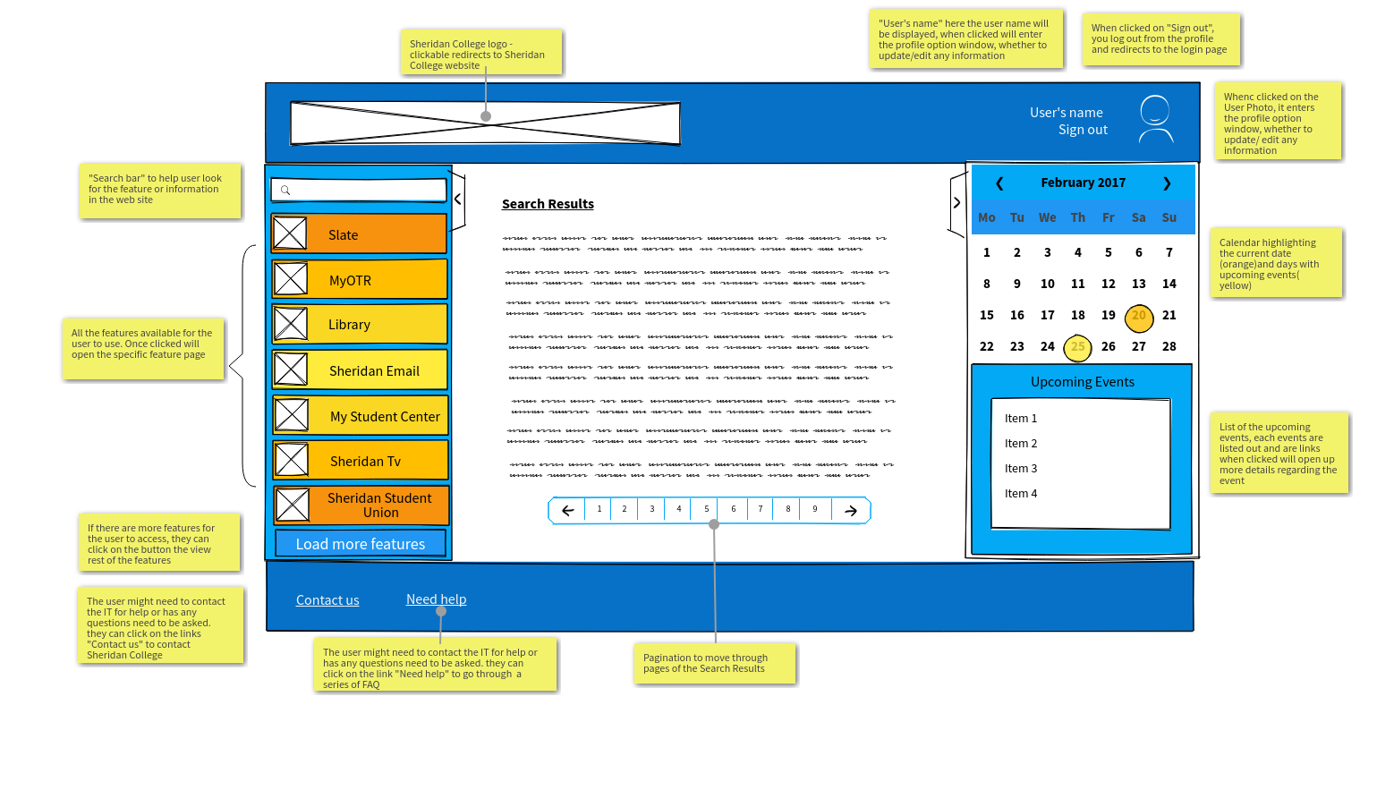

Figure 3a: Initial wireframe for our search result page (wireframe pro)

**Revised Search Page**

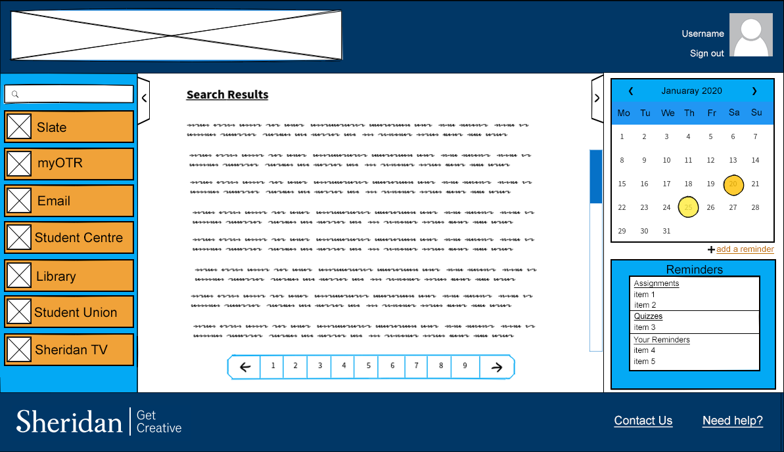

Figure 3b: Revised wireframe for our search result page

We just changed the color scheme and adjusted the header and footer to be consistent with the revised wireframes.

**Initial Slate Page**

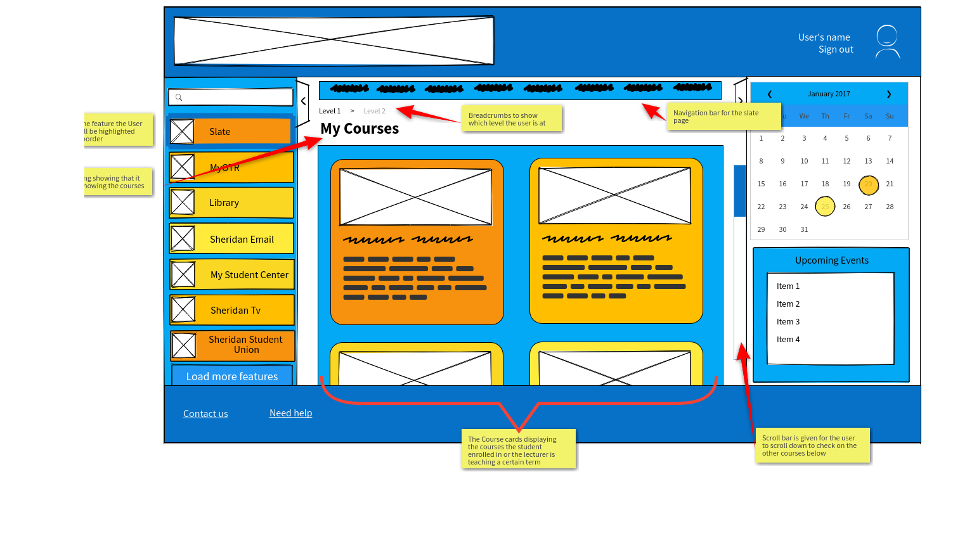

Figure 4a: Initial wireframe for our Slate page (wireframe pro)

**Revised Slate Page**

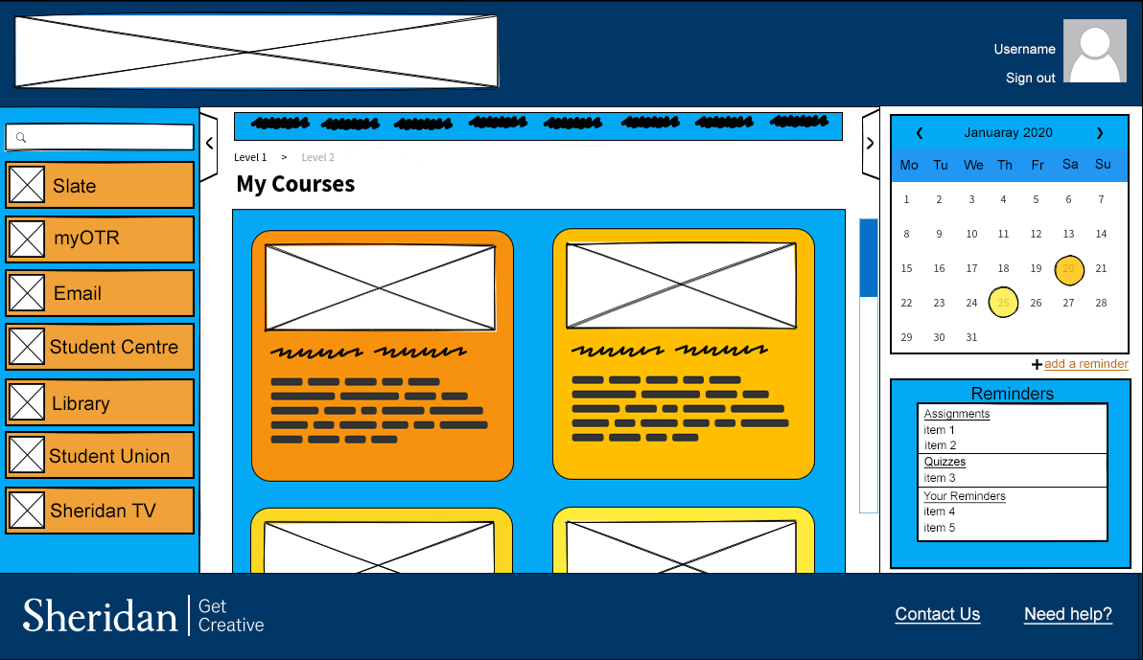

Figure 4b: Revised wireframe for our Slate page

We changed the color to be consistent with the revised wireframes and renaming the “Upcoming Events” to “Reminders” for a better understanding of what it does.

**Initial My OTR Page**

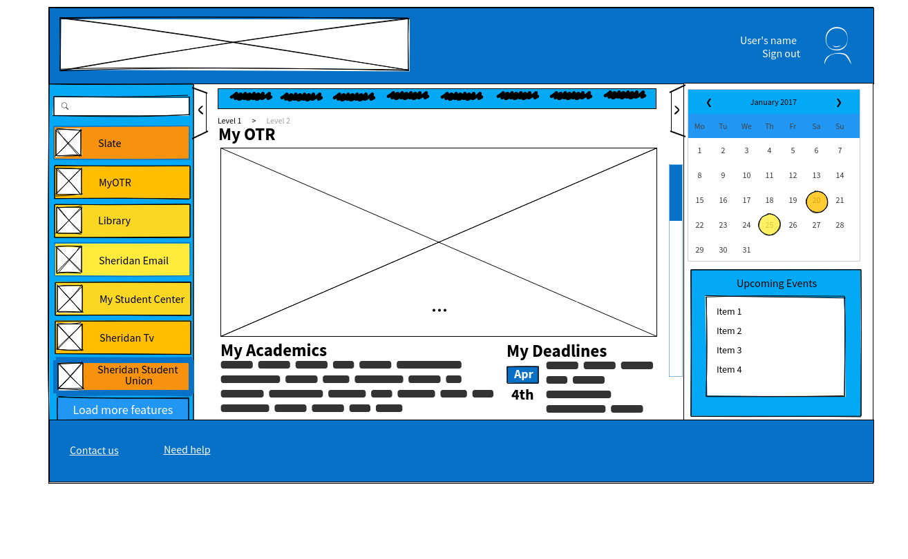

Figure 5a: Initial wireframe for our MyOTR page (wireframe pro)

**Revised My OTR Page**

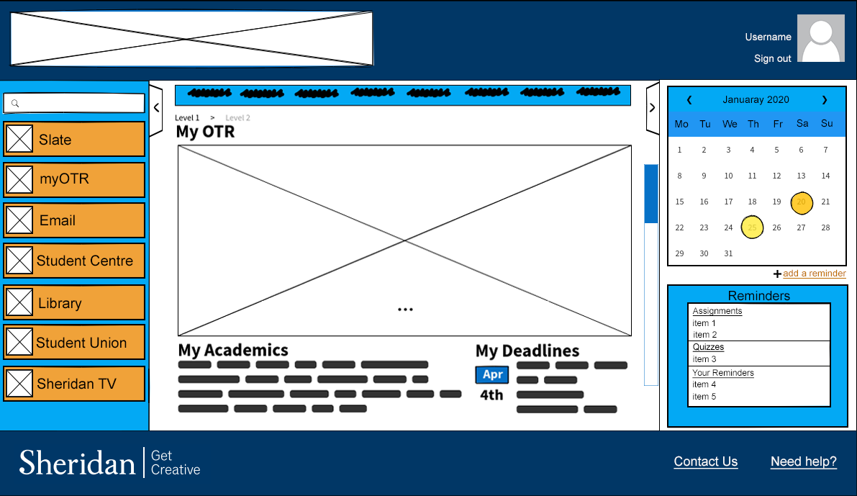

Figure 5b: Revised wireframe for our MyOTR page

we changed the color to be consistent with the revised wireframes.

**Initial Sheridan Email Page**

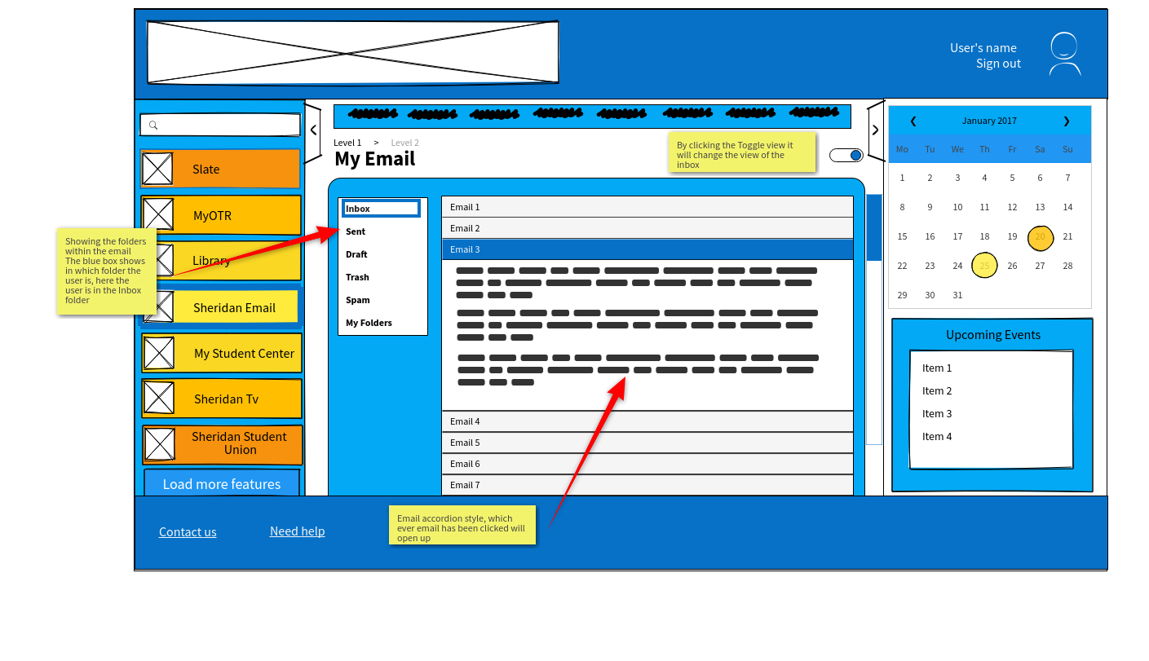

Figure 6a: Initial wireframe for our Sheridan Email page (wireframe pro)

**Revised Sheridan Email Page**

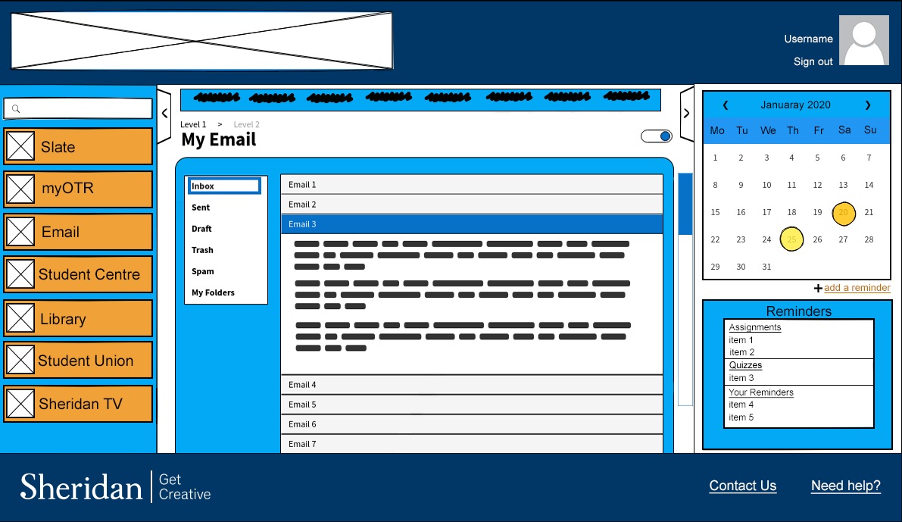

Figure 6b: Revised wire frame for our Sheridan Email page

We changed the color to be consistent with the revised wireframes

**Initial Sheridan Student Union Page**

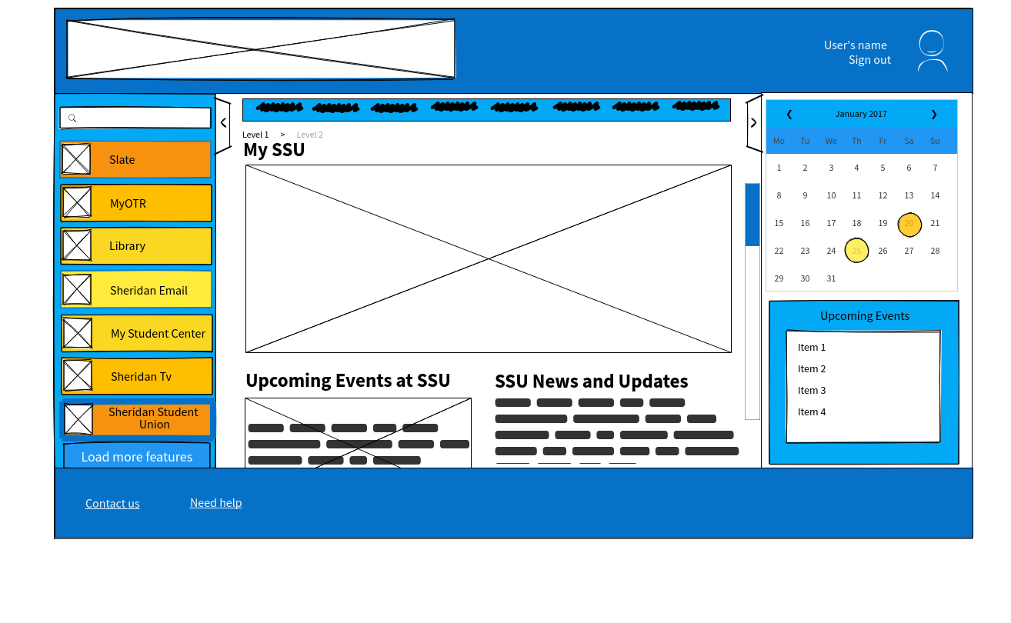

Figure 7a: Initial wireframe for our Sheridan Student Union page (wireframe pro)

**Revised Sheridan Student Union Page**

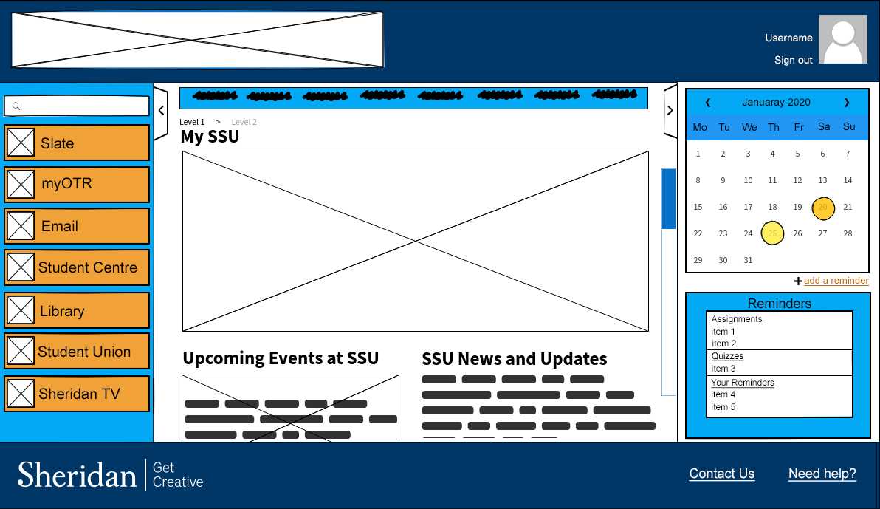

Figure 7b: Revised wireframe for our Sheridan Student Union page

We changed the color to be consistent with the revised wireframes.

**Initial Library Services Page**

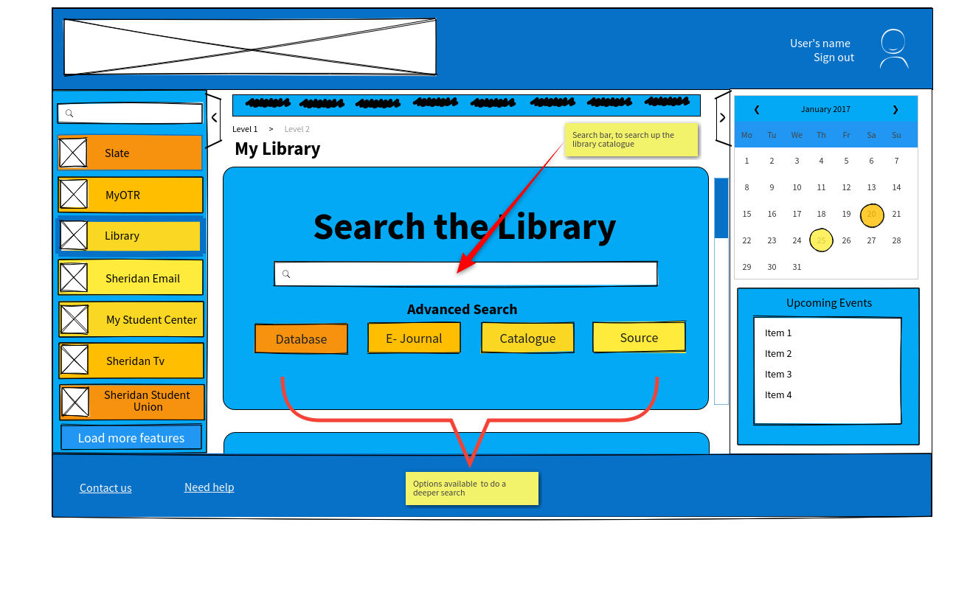

Figure 8a: Initial wireframe for our Library Services page (wireframe pro)

**Revised Library Services Page**

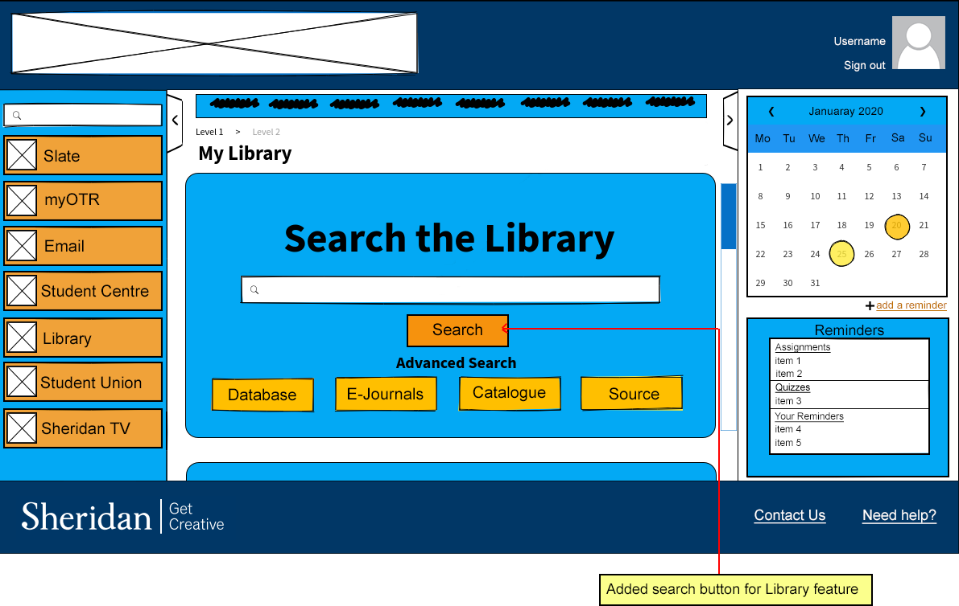

Figure 8b: Revised wireframe for our Library Services page

In this page we added the “Search” button as suggested by one of the users.

**Report Summary**